Pokhara University

Level: Bachelor | Semester – Spring | Year : 2006
Programme: BE |  | Full Marks: 100
Course: Applied Mechanics |  | Time : 3hrs.

Candidates are required to give their answers in their own words as far as practicable.
The figures in the margin indicate full marks.

Attempt all the questions.

 | - The frame ACD is hinged at A and D and is supported by a cable which passes through a ring at B and is attached to hooks at G and H as shown in following figure. Knowing that the tension in the cable is 450 N, determine the moment about the diagonal AD of the force exerted on the frame by portion BH of the cable.  B  0.75 m  x  z  y  0.925 m  0.875 m  0.75 m  0.35 m  O  G  H  A  D  0.5 m  0.5 m  P  - Two spheres A and B of weight 100N and 150N and radius 30cm and 40cm respectively are placed in a vessel as shown in figure. Find the reactions at the contract points. Assume that contract surfaces are smooth.  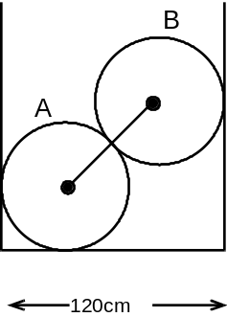 | 7  8
 | - Determine the moment of inertia I_{xx} and I_{yy} with respect to centroidal axis of the areas shown in following figure. All dimensions are mm.  200  20  15  15  100  - Referring the figure shown, determine the least value of the force P to cause motion to impend rightwards. Assume the coefficients of friction under the blocks to be 0.2 and pulley to be frictionless  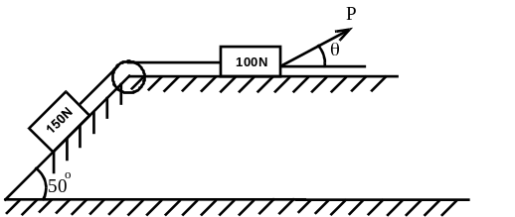 | 8  7
 | - A small projectile is fired vertically downward into a fluid medium with an initial velocity of 60m/s. Due to the resistance of the fluid the projectile Experience a deceleration equal to a = (-0.4v³) m/sec² where v is in m/s. Determine the projectile's velocity and position 4 s after it is fired.  - An outdoor track is 126m in diameter. A runner increases her speed at a constant rate from 4.2 to 7.2m/s over a distance of 28.5m. Determine the total acceleration of the runner 2 sec after she begins to increase her speed. | 7  8
 | A 25 kg projectile is moving with a velocity of 40m/s. It explodes into two fragments A and B, of mass equal to 9 kg and 16kg respectively. Knowing that immediately after explosion they travel in the direction shown, determine the velocity of each fragment.  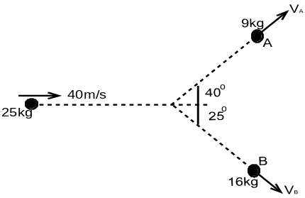  OR  Two masses of 14kg and 7 kg connected by a flexible inextensible cord rest on a smooth plane inclined 45º with the horizontal as shown in figure 4. When the masses are released, what will be the tension T in the cord? Assume the coefficient of friction between the plane and the 14kg mass is ¼ and between the plane and the 7 kg mass is 3/8.  7 kg  14 kg  45° | 15  15
 | - The motion of a particle is defined by the relation x = 2t³-6t²+10 where x is expressed in meters and t in seconds. Determine the time, position and acceleration when v = 0.  - A pulley weighing 50kg and having a radius of gyration of 0.4m is connected to two blocks as shown. Assuming the no axle friction, determine the angular acceleration of the pulley and the acceleration of each block.  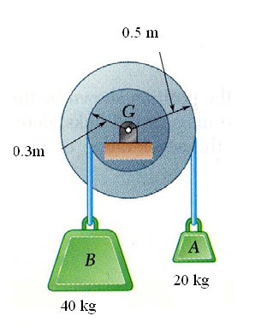 | 5  10
 | - Define translation rotation and plane motion of rigid bodies with example.  - A sphere having the mass m and radius r are released from rest on an incline as shown in following figure. Determine the velocity of sphere after it has rolled through a distance corresponding to a change in elevation h.  OR  A 12 kg collar slides without friction along a vertical rod as shown in following figure. The spring attached to the collar has an under formed length of 125mm and a constant of 400 N/m. If the collar is released from rest in position 1, determine its velocity after it has moved 140mm down.  140 mm  200 mm  1 | 7  8  15
 | Write short notes on (Any Two):  - Free body diagram  - Perpendicular axis theorem  - Radial and transverse components of acceleration.  - Central and oblique impact | 5×2

